Homework 7 (50 pts) due 11/30

1. (10) A soft drink manufacturer uses five agents to handle premium distributions for its various products. The marketing director desired to study the timeliness with which the premiums are distributed. Twenty transactions for each agent were selected at random, and the time lapse (in days) for handling each transaction was determined. The results are in premium.txt.

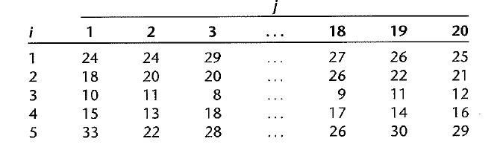

a) Use aligned box plots to compare the factor level means. Do they appear to be different? Does the variability of the observations within each factor level appear to be approximately the same for all factor levels?

Figure 1.

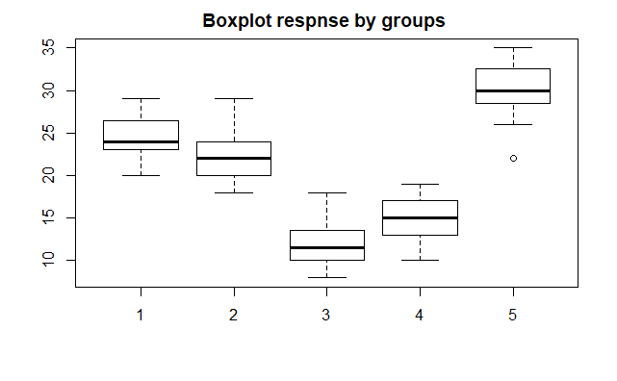

According to Figure 1, the factor level means are different for the five agents. The variability of the observations within each factor level also appears to be approximately same for all factor levels.

b) Obtain the fitted values.

Method 1.

Figure 2.

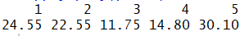

From textbook, the fitted value for observation $Y_{ij}$, denoted by ${\hat{Y}}_{ij}$ for regression models, is simply the corresponding factor level sample mean here:

$${\overline{Y}}_{ij}={\hat{Y}}_{ij}$$

According to Figure 2, the fitted values (factor means) are

24.55, 22.55, 11.75, 14.8, 30.1 for each of the factor level.

Method 2.

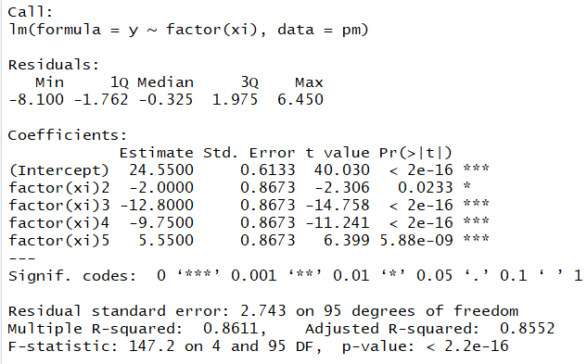

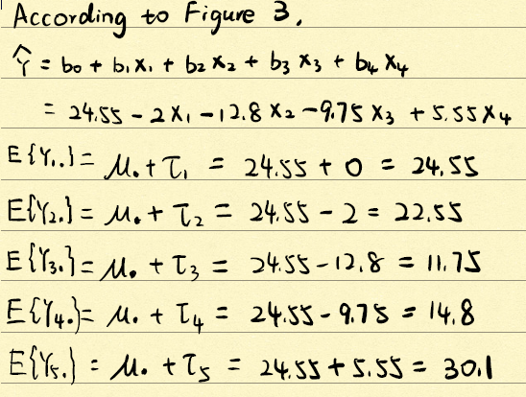

c) Obtain the residues. Do they sum to zero as in the regression model?

Figure 4.

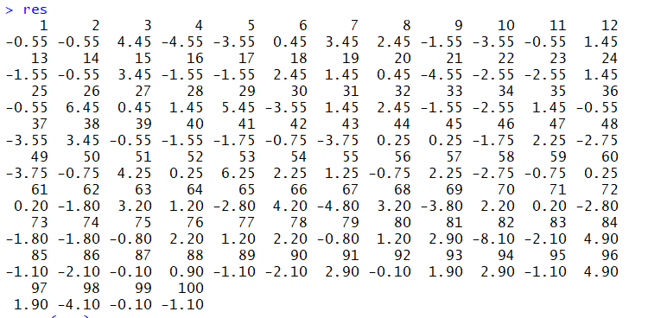

Figure 5.



It sums to 3.802514e-15, which is approximately equal to zero.

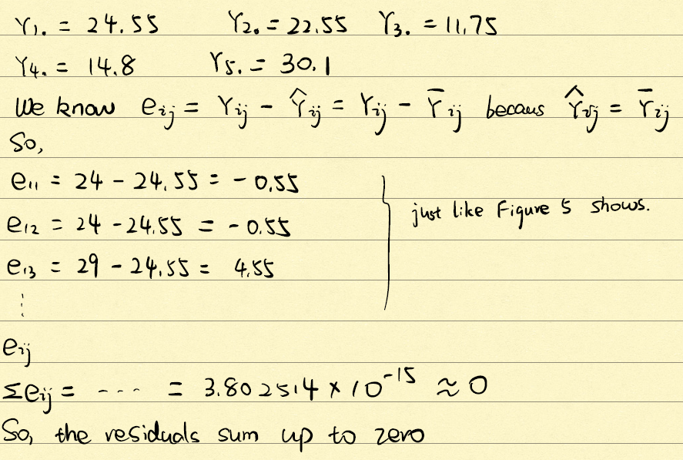

d) Obtain the analysis of variance table.

Figure 6.

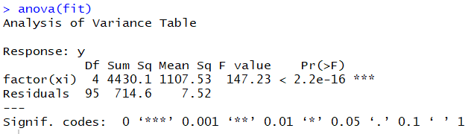

e) Test whether or not the mean time lapse differs for the five agents; use $α=0.1.$ State the alternatives, decision rule, and conclusion.

Figure 7.

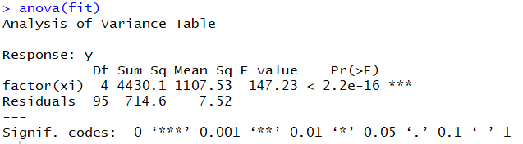

$$H_{0}: μ_{1}=μ_{2}=μ_{3}=μ_{4}=μ_{5}$$

$$H_{a}:at least one of them is diffierent$$

From Figure 6,

dfR=r-1=5-1=4

$$F^{*}=\frac{MSR}{MSE}=\frac{\frac{SSR}{df}}{MSE}=\frac{\frac{4430.1}{4}}{7.52}=147.27726$$

F (1- $α$; r-1, $n_{T}-r$) = F (0.9; 4, 95) = 2.005 < $F^{*}$ = $147.27726$

Decision rule: reject $H_{0}$ if $F^{*}$ > 2.005, do not reject ${ H}_{0}$ if $F^{*}$ < 2.005

So, we reject $H_{0}$, not all $μ$ are equal

We are 90% confident that at least one of the factor level means is different from others.

f) Test assumption for the test.

The samples are randomly selected and independent.

Figure 8.

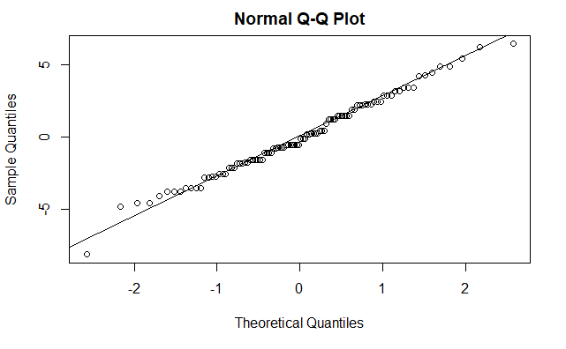

From the Normal probability plot, the residual points fit the line well, and they have a normal distribution.

Figure 9.

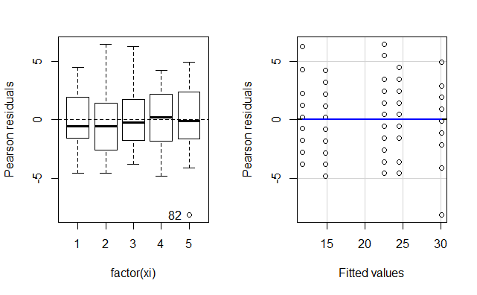

From Figure 8, the distributions of residuals have a random pattern around 0 line, which means the relationship is linear is reasonable and the residuals have constant variances.

2. (6) Refer toproblem 1, suppose that 25 percent of all premium distribution are handled by agent1, 20 percent by agent 2, 20 percent by agent 3, 20 percent by agent 4, and 15 percent by agent 5.

a) Obtain a point estimate of the grand mean $μ$. when the ANOVA model is expressed in the factor effects with the weighs being the proportions of premium distribution handled by each agent.

$$μ.=Σw_{i}μ_{i}$$

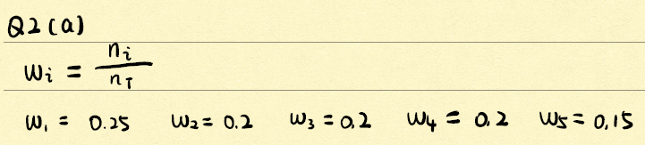 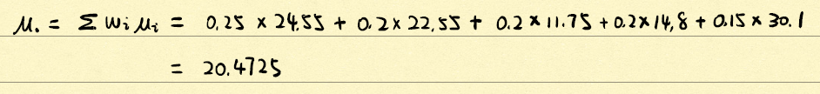

b) Test whether or not the mean lapse differs for the five agents; use $=0.1.$ State the alternatives, decision rule, and conclusion.

Figure 1.

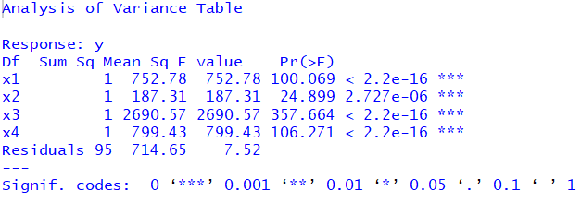

$$H_{0}: μ_{1}=μ_{2}=μ_{3}=μ_{4}=μ_{5}$$

$$H_{a}:at least one of them is diffierent$$

From Figure 10,

dfR=r-1=5-1=4

$$F^{*}=\frac{MSR}{MSE}=\frac{\frac{SSR}{df}}{MSE}=\frac{\frac{752.78+187.31+2690.57+799.43}{4}}{7.52}=\frac{\frac{4430.09}{4}}{7.52}=147.2769$$

F (1- $α$; r-1, $n_{T}-r$) = F (0.9; 4, 95) = 2.005 < $F^{*}$ = $147.2769$

Decision rule: reject $H_{0}$ if $F^{*}$ > 2.005, do not reject ${ H}_{0}$ if $F^{*}$ < 2.005

So, we reject $H_{0}$, not all $μ$ are equal

We are 90% confident that at least one of the factor level means is different from others.

3. (8) Refer to problem 1,

a) Construct a 90% confidence interval for the mean time lapse for agent 1.

Figure 1.

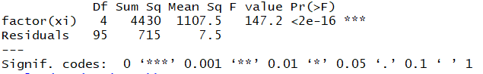

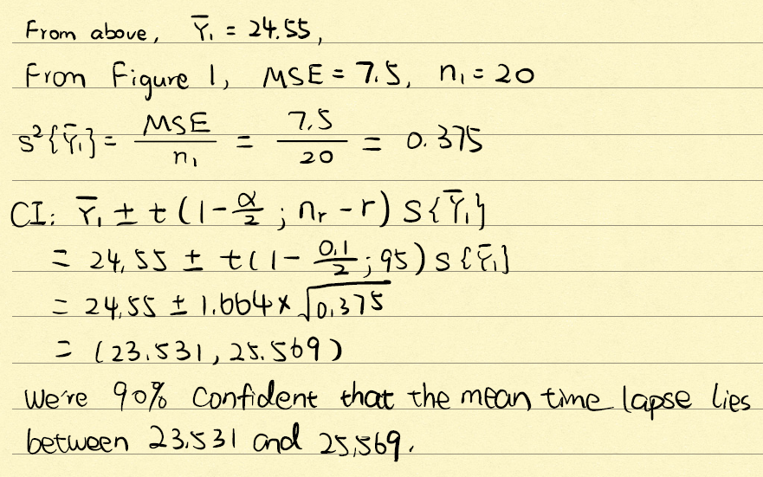

b) Obtain a 90% confidence interval for $μ_{2}-μ_{1}$. Interpret your interval estimate.

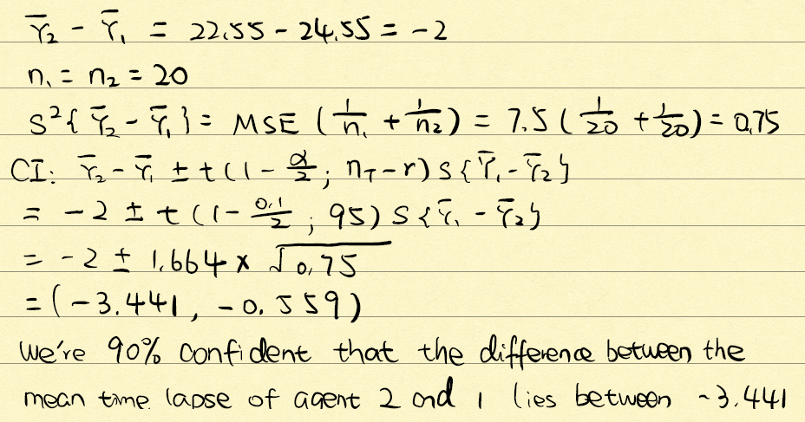 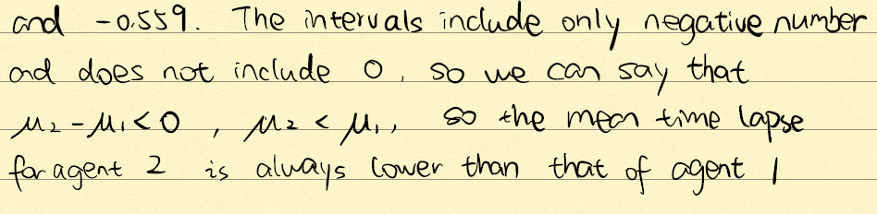

c) The marketing director wishes to compare the mean time lapses for agents 1, 3, and 5. Obtain confidence interval for all pairwise comparisons among these three treatment means; use the Bonferroni procedure with a 90% family level.

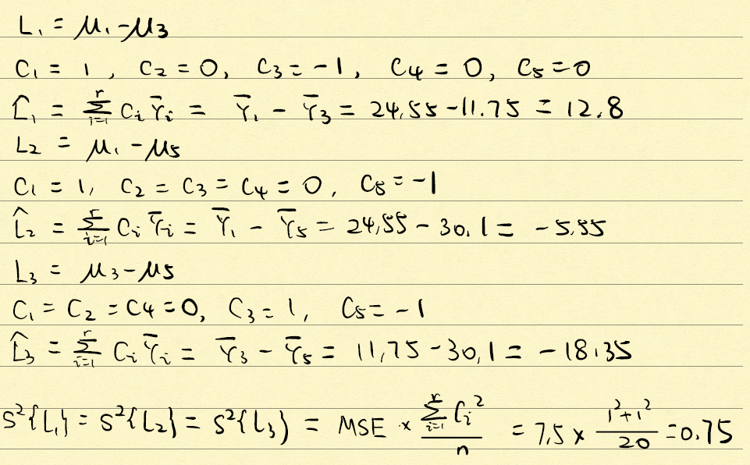 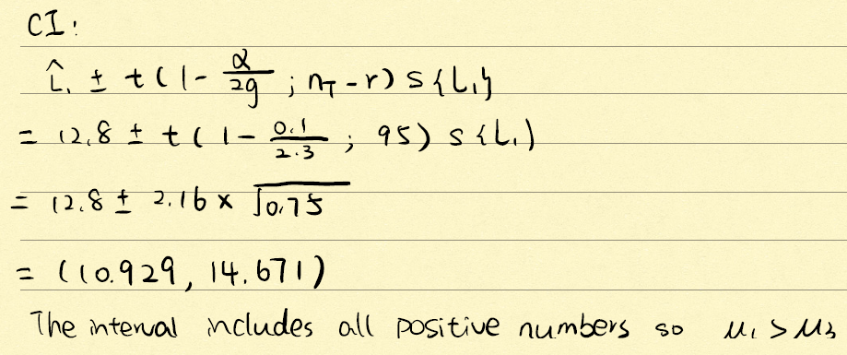 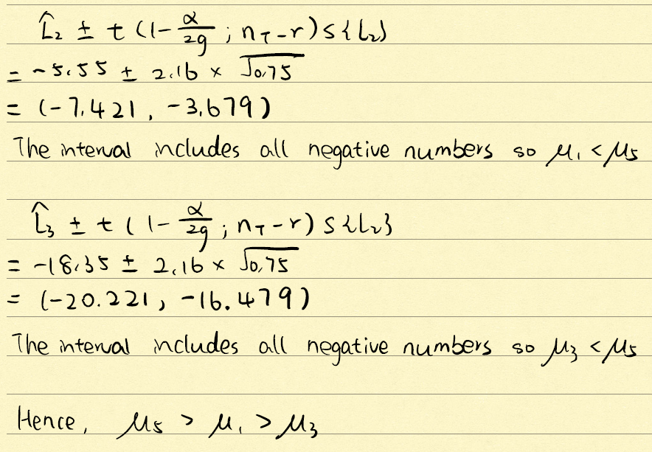

4. (6) Refer to problem 1, suppose primary interest is in estimating the following comparisons:

$$L1=\frac{μ_{1}+μ_{2}}{2}-μ_{5}$$

$$L2=\frac{μ_{1}+μ_{2}}{2}-\frac{\left(μ_{3}+μ_{4}\right)}{2}$$

a) Obtain a 90% confidence interval for individual comparison.

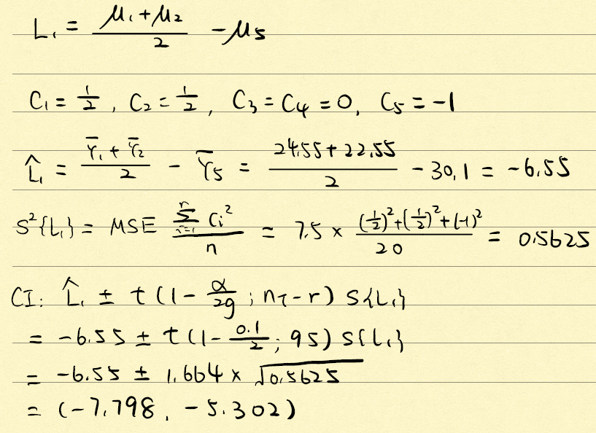 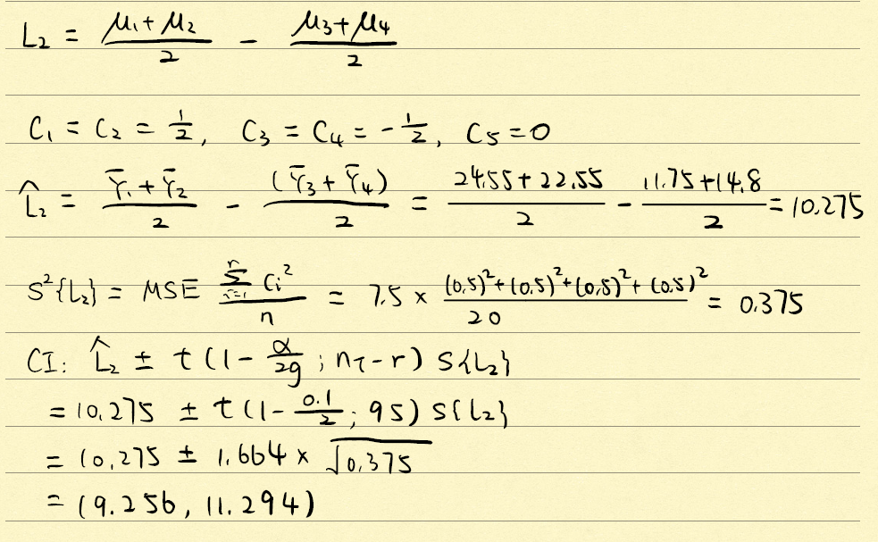

b) Obtain a 90% simultaneous confidence interval for the two comparisons.

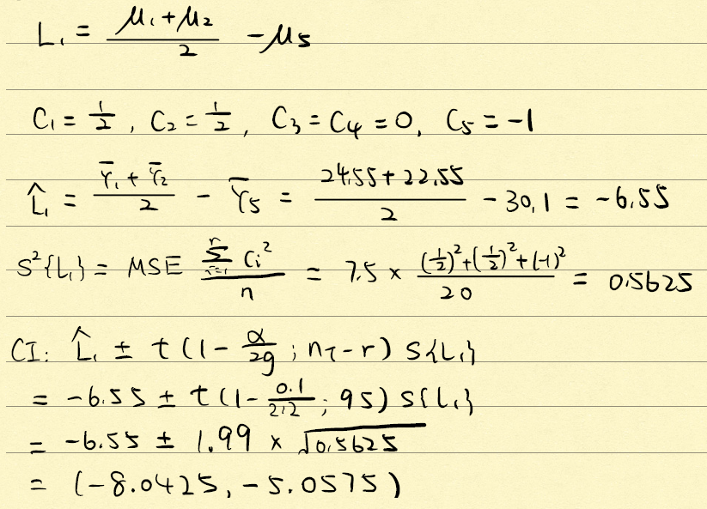 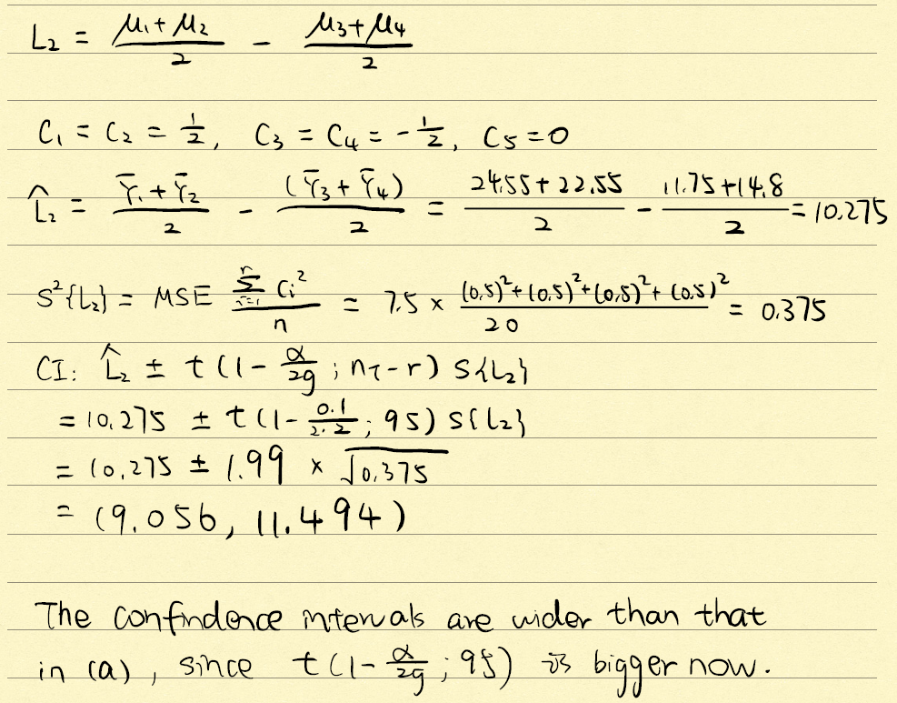

5. (10) A computer software firm was encountering difficulties in forecasting the programmer requirements for large0scale programming projects. Twenty-four programmers are classified into equal groups by type of experience (factor A) and amount of experience (factor B), were asked to predict the number of programmer days required to complete a large project about to be initiated. After this project was completed, the prediction errors (actual minus predicted programmer-days) were determined. The data is in programmer.txt.

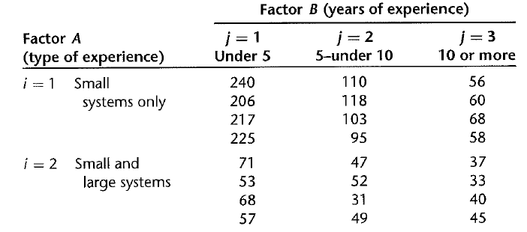

a) Prepare an estimated means plot. Does your graph suggest that any main factor or interaction effects are present? Explain.

Figure 1.

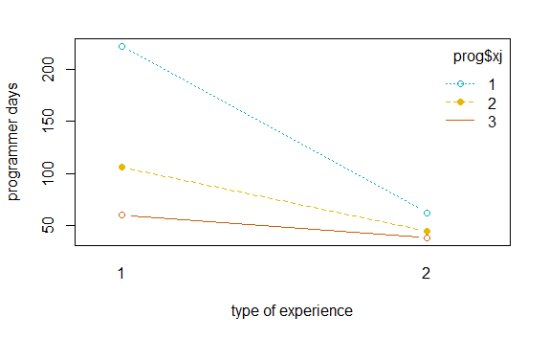

The slopes of these lines are very different from each other, so there must be main factor effects and interaction effect.

We can see that the mean of the left vertical line combing the three left end points of the three lines is about 125 days and the mean of the right vertical line combing the three right end points of the three lines is about 60, so there exists main factor effects for type of experience.

Moreover, the midpoint of the type of experience has three different means, 55, 80, 145, which are very different, so there exists main factor effects for years of experience.

The slope of the three lines are far from equal, and we can see that they are no parallel to each other, so there must have interaction effect.

b) Obtain the ANOVA table. Does any one source account for most of the total variability?

Figure 2.

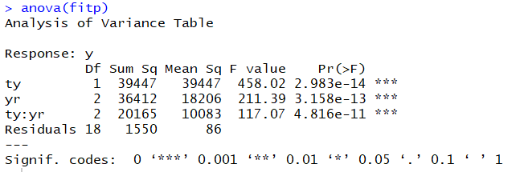

From Figure 2, the type of experience accounts for most of the total variability.

c) Test whether the two factors interact; use 0.01 significant level.

$$H_{0}: all {αβ}_{ij}=0$$

$$H_{a}:at least one of them is not 0$$

From Figure 2,

MSAB =10083, MSE=86

$$F^{*}=\frac{MSAB}{MSE}=\frac{10083}{86}=117.244186$$

F (0.99; 2, 18) = 6.36 < $F^{*}$ = $117.244186$

Decision rule: reject $H_{0}$ if $F^{*}$ > 6.36 do not reject ${ H}_{0}$ if $F^{*}$ < 6.36

So, we reject $H_{0}$, not all of them are zeros

We are 99% confident that at least one of them is not zero, so the two factors have interaction.

d) Test whether the main effects are present, use 0.01 significant level.

For type of experience:

$$H_{0}: all α_{ij}=0$$

$$H_{a}:at least one of them is not 0$$

From Figure 2,

MSA=39447, MSE=86

$$F^{*}=\frac{MSA}{MSE}=\frac{39447}{86}=458.686$$

F (0.99; 1, 18) = 8.68 < $F^{*}$ = $458.686$

Decision rule: reject $H_{0}$ if $F^{*}$ > 8.68 do not reject ${ H}_{0}$ if $F^{*}$ < 8.68

So, we reject $H_{0}$, not all of them are zeros

We are 99% confident that at least one of them is not zero, so the type of experience has main effects.

For years of experience:

$$H_{0}: all β_{ij}=0$$

$$H_{a}:at least one of them is not 0$$

From Figure 2,

MSB=18206, MSE=86

$$F^{*}=\frac{MSB}{MSE}=\frac{18206}{86}=211.6976744$$

F (0.99; 2, 18) = 6.36 < $F^{*}$ = $211.6976744$

Decision rule: reject $H_{0}$ if $F^{*}$ > 6.36 do not reject ${ H}_{0}$ if $F^{*}$ < 6.36

So, we reject $H_{0}$, not all of them are zeros

We are 99% confident that at least one of them is not zero, so the years of experience has main effects.

6. (10) Refer to question 5,

a) Estimate $μ_{23}$ with 99 percent confidence interval. Interpret your estimate.

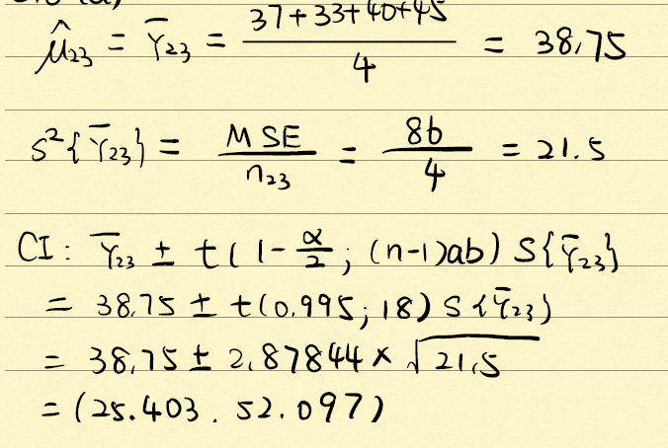 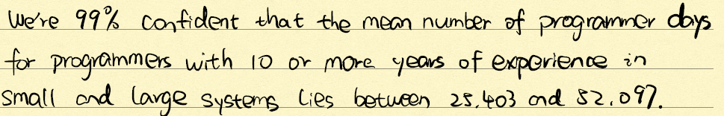

b) Estimate $D=μ_{12}-μ_{13}$ with 99% confidence interval. Interpret your estimate.

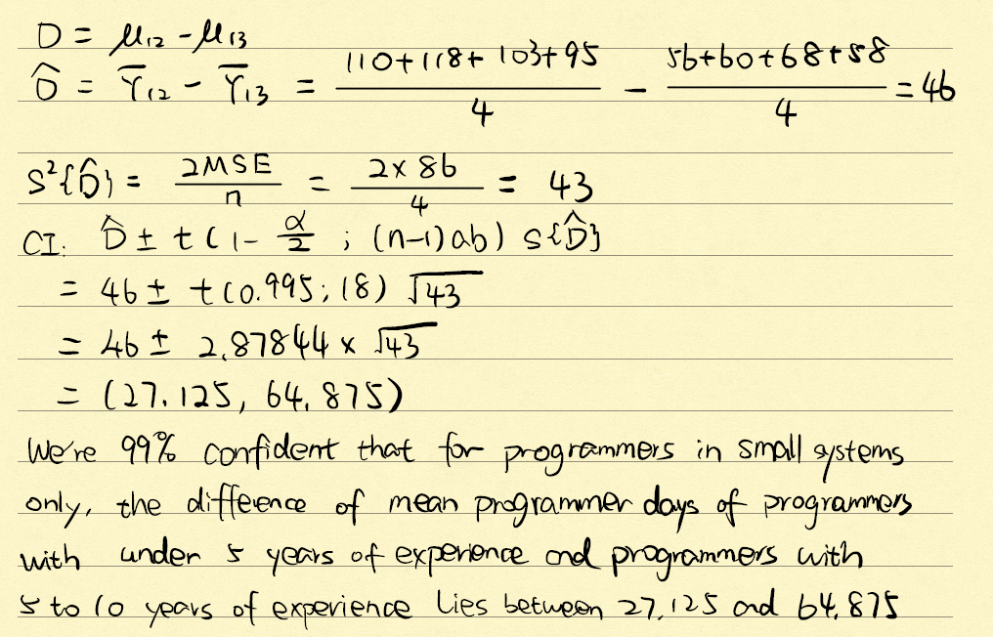

c. The nature of the interaction effects is to be studied by comparing the effect of type of experience for each years-of-experience group. Specifically, the following comparisons are to be estimated:

$L_{1}=(μ_{11}-μ_{21})-(μ_{12}-μ_{22}$)

$L_{2}=(μ_{11}-μ_{21})-(μ_{13}-μ_{23}$)

$$L_{3}=(μ_{12}-μ_{22})-(μ_{13}-μ_{23})$$

Obtain a simultaneous confidence interval, with 95% level.

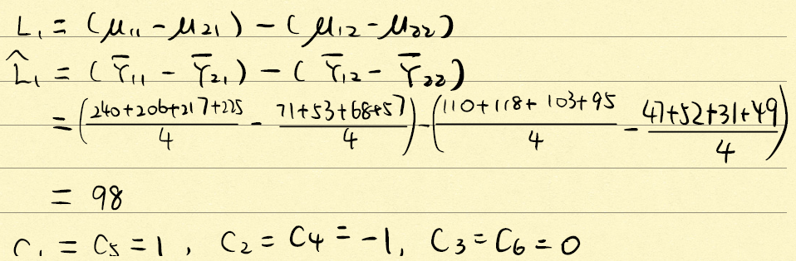

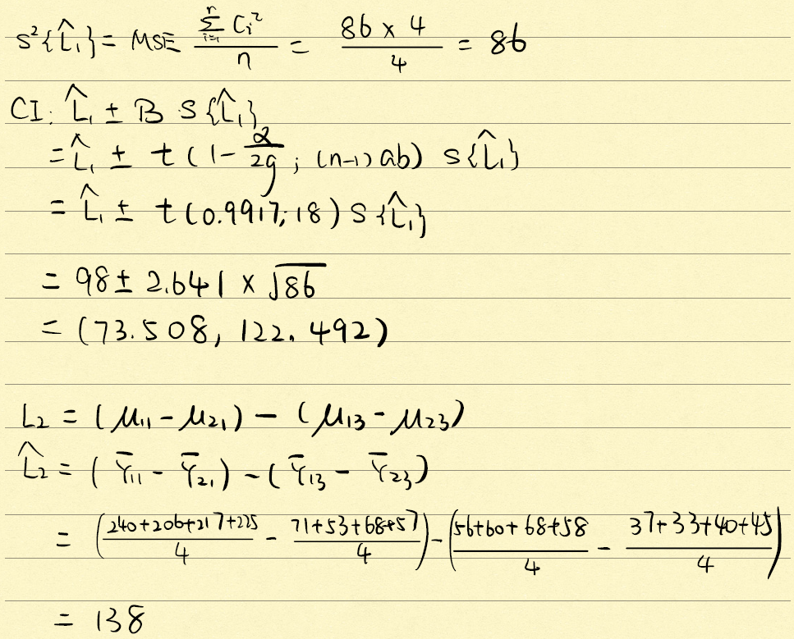 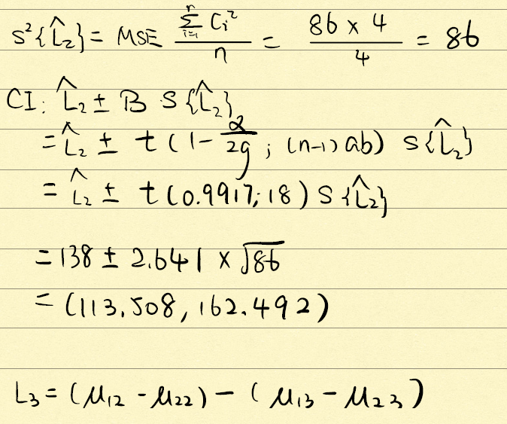 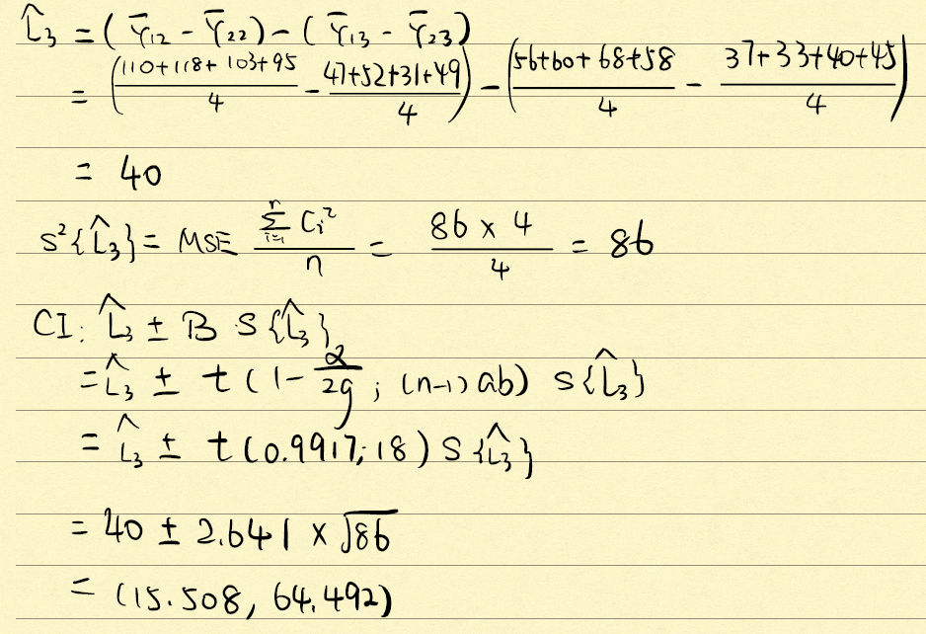

d) To examine whether a transformation of the data would make the interaction unimportant, plot separately the transformed estimated means for the reciprocal ( $1/Y)$ and logarithmic transformation (log(Y)). Would either of these transformations have made the interaction effects unimportant?

Figure 1. reciprocal ($1/Y)$

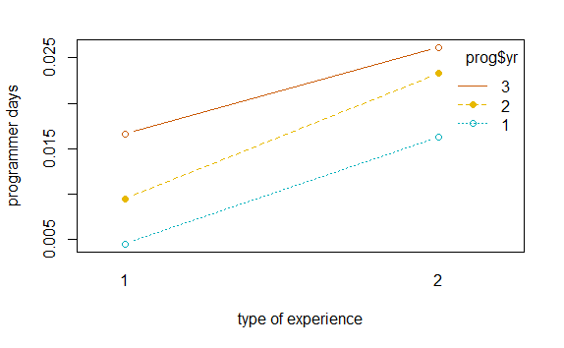

Figure 2. logarithmic transformation (log(Y))

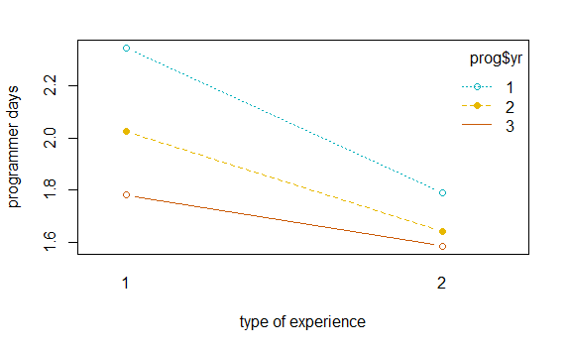

From Figure 1, these lines look more parallel teach other and their slopes are close to equal, so the reciprocal transformations have made the interaction effects unimportant. From Figure 2, these looks a little bit more parallel to each other and the difference of their slopes are lower than before, so the logarithmic transformation have made the interaction effects less important to some extent, but not as well as the reciprocal transformation did.

Appendix

# HW7 Premium

pm<-read.table("C:/Users/candi/Desktop/STAT 512/premium.txt",header=FALSE)  
colnames(pm)<-c('y','xi','xj')  
colClasses<-c('numeric','factor','factor')  
pm

## y xi xj  
## 1 24 1 1  
## 2 24 1 2  
## 3 29 1 3  
## 4 20 1 4  
## 5 21 1 5  
## 6 25 1 6  
## 7 28 1 7  
## 8 27 1 8  
## 9 23 1 9  
## 10 21 1 10  
## 11 24 1 11  
## 12 26 1 12  
## 13 23 1 13  
## 14 24 1 14  
## 15 28 1 15  
## 16 23 1 16  
## 17 23 1 17  
## 18 27 1 18  
## 19 26 1 19  
## 20 25 1 20  
## 21 18 2 1  
## 22 20 2 2  
## 23 20 2 3  
## 24 24 2 4  
## 25 22 2 5  
## 26 29 2 6  
## 27 23 2 7  
## 28 24 2 8  
## 29 28 2 9  
## 30 19 2 10  
## 31 24 2 11  
## 32 25 2 12  
## 33 21 2 13  
## 34 20 2 14  
## 35 24 2 15  
## 36 22 2 16  
## 37 19 2 17  
## 38 26 2 18  
## 39 22 2 19  
## 40 21 2 20  
## 41 10 3 1  
## 42 11 3 2  
## 43 8 3 3  
## 44 12 3 4  
## 45 12 3 5  
## 46 10 3 6  
## 47 14 3 7  
## 48 9 3 8  
## 49 8 3 9  
## 50 11 3 10  
## 51 16 3 11  
## 52 12 3 12  
## 53 18 3 13  
## 54 14 3 14  
## 55 13 3 15  
## 56 11 3 16  
## 57 14 3 17  
## 58 9 3 18  
## 59 11 3 19  
## 60 12 3 20  
## 61 15 4 1  
## 62 13 4 2  
## 63 18 4 3  
## 64 16 4 4  
## 65 12 4 5  
## 66 19 4 6  
## 67 10 4 7  
## 68 18 4 8  
## 69 11 4 9  
## 70 17 4 10  
## 71 15 4 11  
## 72 12 4 12  
## 73 13 4 13  
## 74 13 4 14  
## 75 14 4 15  
## 76 17 4 16  
## 77 16 4 17  
## 78 17 4 18  
## 79 14 4 19  
## 80 16 4 20  
## 81 33 5 1  
## 82 22 5 2  
## 83 28 5 3  
## 84 35 5 4  
## 85 29 5 5  
## 86 28 5 6  
## 87 30 5 7  
## 88 31 5 8  
## 89 29 5 9  
## 90 28 5 10  
## 91 33 5 11  
## 92 30 5 12  
## 93 32 5 13  
## 94 33 5 14  
## 95 29 5 15  
## 96 35 5 16  
## 97 32 5 17  
## 98 26 5 18  
## 99 30 5 19  
## 100 29 5 20

library(ALSM)

## Loading required package: leaps

## Loading required package: SuppDists

## Loading required package: car

## Loading required package: carData

#install.packages("lmtest")  
library(lmtest)

## Loading required package: zoo

##   
## Attaching package: 'zoo'

## The following objects are masked from 'package:base':  
##   
## as.Date, as.Date.numeric

library(zoo)  
library(data.table)  
  
#(a)  
oneway(pm$y,pm$xi)

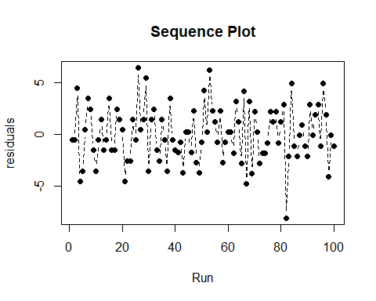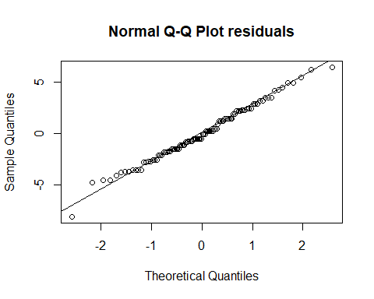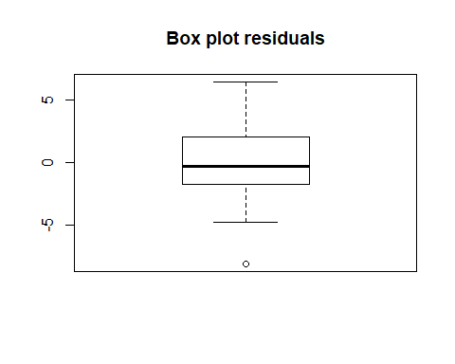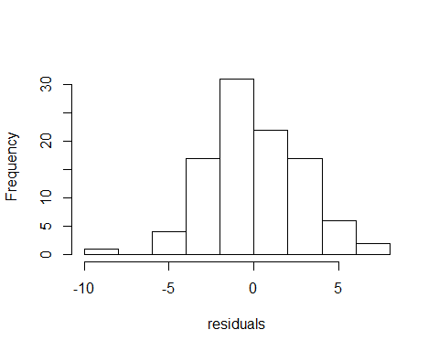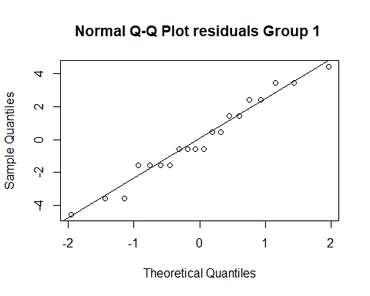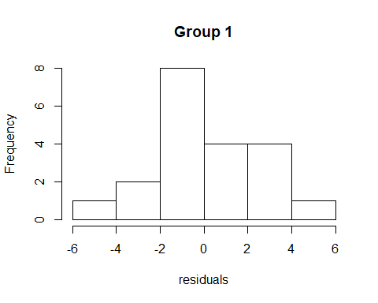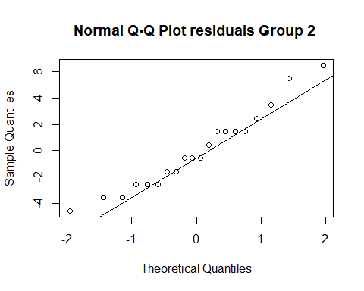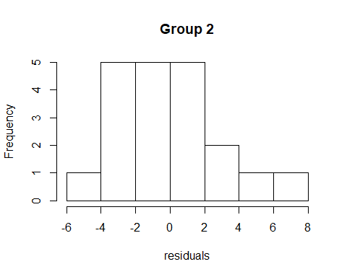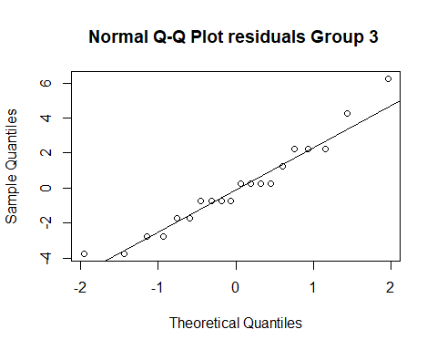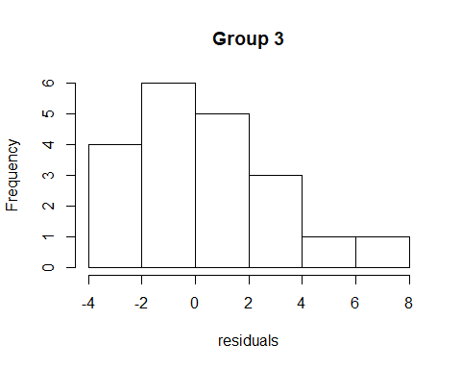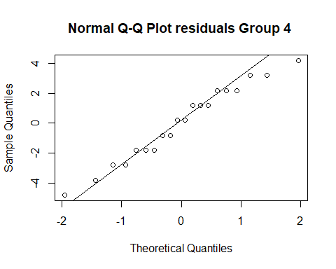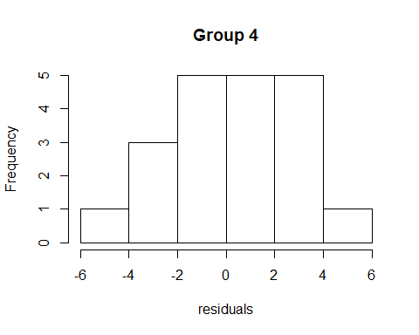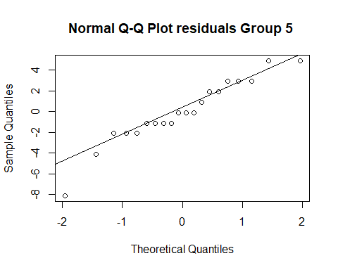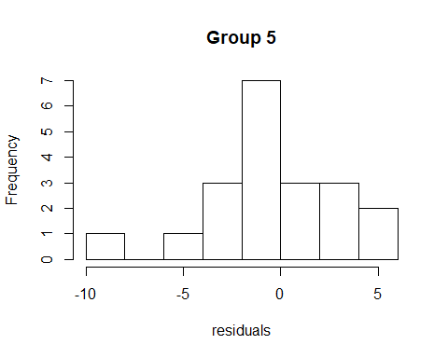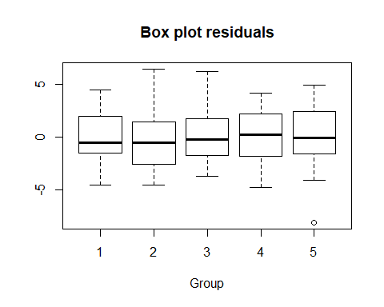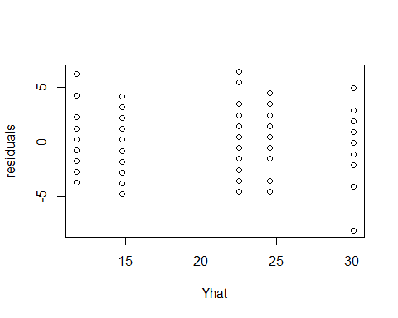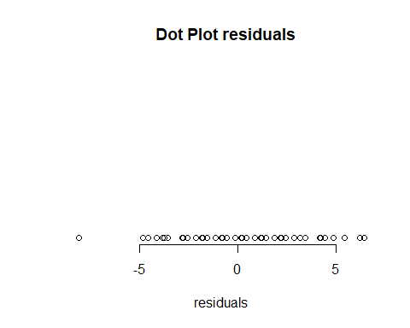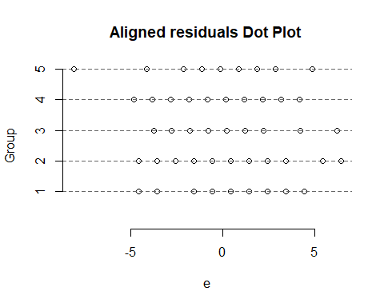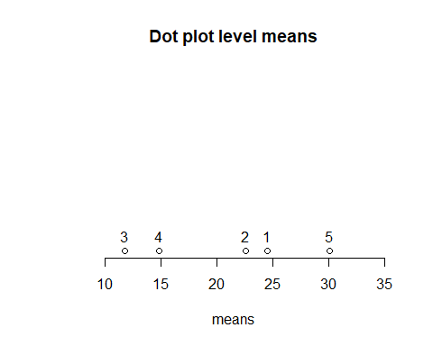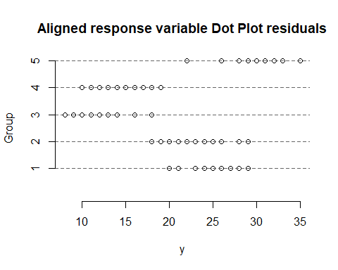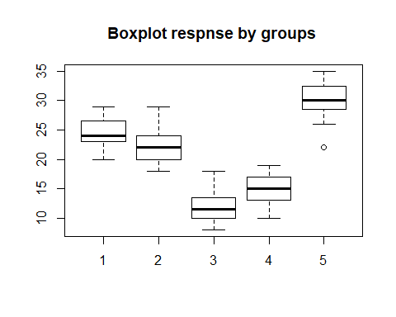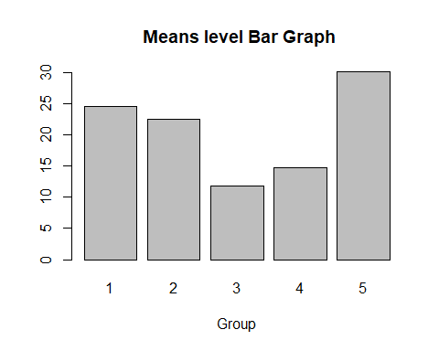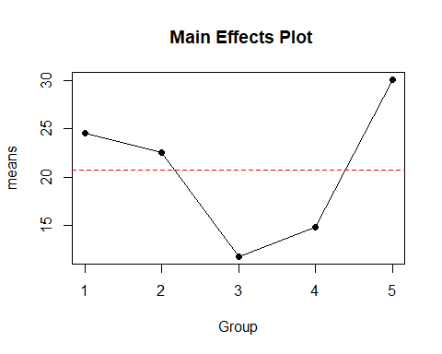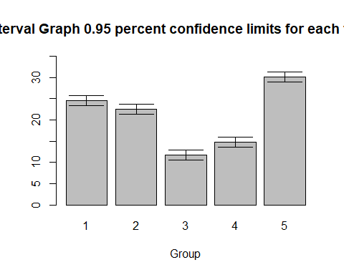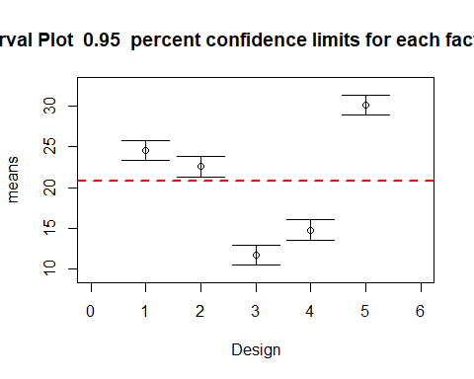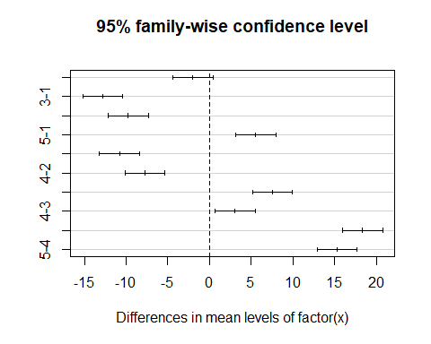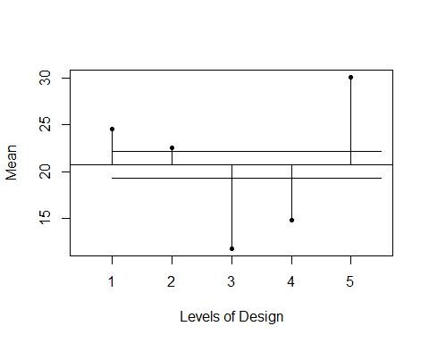

## $descriptive  
## Group n mean median Var SD min max  
## 1 1 20 24.55 24.0 6.155263 2.480980 20 29  
## 2 2 20 22.55 22.0 8.892105 2.981963 18 29  
## 3 3 20 11.75 11.5 6.618421 2.572629 8 18  
## 4 4 20 14.80 15.0 6.378947 2.525658 10 19  
## 5 5 20 30.10 30.0 9.568421 3.093286 22 35  
##   
## $fit  
##   
## Call:  
## lm(formula = y ~ factor(x))  
##   
## Residuals:  
## Min 1Q Median 3Q Max   
## -8.100 -1.762 -0.325 1.975 6.450   
##   
## Coefficients:  
## Estimate Std. Error t value Pr(>|t|)   
## (Intercept) 24.5500 0.6133 40.030 < 2e-16 ***  
## factor(x)2 -2.0000 0.8673 -2.306 0.0233 *   
## factor(x)3 -12.8000 0.8673 -14.758 < 2e-16 ***  
## factor(x)4 -9.7500 0.8673 -11.241 < 2e-16 ***  
## factor(x)5 5.5500 0.8673 6.399 5.88e-09 ***  
## ---  
## Signif. codes: 0 '***' 0.001 '**' 0.01 '*' 0.05 '.' 0.1 ' ' 1  
##   
## Residual standard error: 2.743 on 95 degrees of freedom  
## Multiple R-squared: 0.8611, Adjusted R-squared: 0.8552   
## F-statistic: 147.2 on 4 and 95 DF, p-value: < 2.2e-16  
##   
##   
## $anova  
## Analysis of Variance Table  
##   
## Response: y  
## Df Sum Sq Mean Sq F value Pr(>F)   
## factor(x) 4 4430.1 1107.53 147.23 < 2.2e-16 ***  
## Residuals 95 714.6 7.52   
## ---  
## Signif. codes: 0 '***' 0.001 '**' 0.01 '*' 0.05 '.' 0.1 ' ' 1  
##   
## $Single.factor.level  
## Group size mean lower upper t p-value  
## [1,] 1 20 24.55 23.33245 25.76755 40.02963 0  
## [2,] 2 20 22.55 21.33245 23.76755 36.76856 0  
## [3,] 3 20 11.75 10.53245 12.96755 19.15879 0  
## [4,] 4 20 14.80 13.58245 16.01755 24.13192 0  
## [5,] 5 20 30.10 28.88245 31.31755 49.07910 0  
##   
## $LSD  
## diffrence lower upper t p-value  
## 1 - 2 2.00 0.2781302 3.72187 2.305925 0.023290  
## 1 - 3 12.80 11.0781302 14.52187 14.757917 0.000000  
## 1 - 4 9.75 8.0281302 11.47187 11.241382 0.000000  
## 1 - 5 -5.55 -7.2718698 -3.82813 -6.398941 0.000000  
## 2 - 3 10.80 9.0781302 12.52187 12.451993 0.000000  
## 2 - 4 7.75 6.0281302 9.47187 8.935458 0.000000  
## 2 - 5 -7.55 -9.2718698 -5.82813 -8.704865 0.000000  
## 3 - 4 -3.05 -4.7718698 -1.32813 -3.516535 0.000672  
## 3 - 5 -18.35 -20.0718698 -16.62813 -21.156858 0.000000  
## 4 - 5 -15.30 -17.0218698 -13.57813 -17.640323 0.000000  
##   
## $Tukey  
## Tukey multiple comparisons of means  
## 95% family-wise confidence level  
##   
## Fit: aov(formula = y ~ factor(x))  
##   
## $`factor(x)`  
## diff lwr upr p adj  
## 2-1 -2.00 -4.4119302 0.4119302 0.1520498  
## 3-1 -12.80 -15.2119302 -10.3880698 0.0000000  
## 4-1 -9.75 -12.1619302 -7.3380698 0.0000000  
## 5-1 5.55 3.1380698 7.9619302 0.0000001  
## 3-2 -10.80 -13.2119302 -8.3880698 0.0000000  
## 4-2 -7.75 -10.1619302 -5.3380698 0.0000000  
## 5-2 7.55 5.1380698 9.9619302 0.0000000  
## 4-3 3.05 0.6380698 5.4619302 0.0059245  
## 5-3 18.35 15.9380698 20.7619302 0.0000000  
## 5-4 15.30 12.8880698 17.7119302 0.0000000  
##   
##   
## $Nonparametric.Rank.F.Test  
## F p.value  
## [1,] 140.8225 4.859812e-39  
##   
## $Nonparametric.Rank.F.Test.Pairwise  
## difference lower upper  
## 1 - 2 8.850 -16.9024 34.6024  
## 1 - 3 51.625 25.8726 77.3774  
## 1 - 4 39.400 13.6476 65.1524  
## 1 - 5 -21.875 -47.6274 3.8774  
## 2 - 3 42.775 17.0226 68.5274  
## 2 - 4 30.550 4.7976 56.3024  
## 2 - 5 -30.725 -56.4774 -4.9726  
## 3 - 4 -12.225 -37.9774 13.5274  
## 3 - 5 -73.500 -99.2524 -47.7476  
## 4 - 5 -61.275 -87.0274 -35.5226  
##   
## $Hartley.Test  
## H p-value  
## [1,] 1.55451 0.8775243  
##   
## $Brown.Forsythe.test  
## F value p-value  
## [1,] 0.2493118 0.9094275  
##   
## $Bonfferoni.Test.Outlier  
## [1] "t value=3.60608426808245 ,do not exist outlier"  
##   
## $ANOM.Bonferroni  
## factor level lower upper  
## 1 1 2.3580992 5.241901  
## 2 2 0.3580992 3.241901  
## 3 3 -10.4419008 -7.558099  
## 4 4 -7.3919008 -4.508099  
## 5 5 7.9080992 10.791901  
##   
## $residuals  
## 1 2 3 4 5 6 7 8 9 10 11 12   
## -0.55 -0.55 4.45 -4.55 -3.55 0.45 3.45 2.45 -1.55 -3.55 -0.55 1.45   
## 13 14 15 16 17 18 19 20 21 22 23 24   
## -1.55 -0.55 3.45 -1.55 -1.55 2.45 1.45 0.45 -4.55 -2.55 -2.55 1.45   
## 25 26 27 28 29 30 31 32 33 34 35 36   
## -0.55 6.45 0.45 1.45 5.45 -3.55 1.45 2.45 -1.55 -2.55 1.45 -0.55   
## 37 38 39 40 41 42 43 44 45 46 47 48   
## -3.55 3.45 -0.55 -1.55 -1.75 -0.75 -3.75 0.25 0.25 -1.75 2.25 -2.75   
## 49 50 51 52 53 54 55 56 57 58 59 60   
## -3.75 -0.75 4.25 0.25 6.25 2.25 1.25 -0.75 2.25 -2.75 -0.75 0.25   
## 61 62 63 64 65 66 67 68 69 70 71 72   
## 0.20 -1.80 3.20 1.20 -2.80 4.20 -4.80 3.20 -3.80 2.20 0.20 -2.80   
## 73 74 75 76 77 78 79 80 81 82 83 84   
## -1.80 -1.80 -0.80 2.20 1.20 2.20 -0.80 1.20 2.90 -8.10 -2.10 4.90   
## 85 86 87 88 89 90 91 92 93 94 95 96   
## -1.10 -2.10 -0.10 0.90 -1.10 -2.10 2.90 -0.10 1.90 2.90 -1.10 4.90   
## 97 98 99 100   
## 1.90 -4.10 -0.10 -1.10   
##   
## $semistudentized.residuals  
## 1 2 3 4 5 6   
## -0.20052928 -0.20052928 1.62246417 -1.65892404 -1.29432535 0.16406941   
## 7 8 9 10 11 12   
## 1.25786548 0.89326679 -0.56512797 -1.29432535 -0.20052928 0.52866810   
## 13 14 15 16 17 18   
## -0.56512797 -0.20052928 1.25786548 -0.56512797 -0.56512797 0.89326679   
## 19 20 21 22 23 24   
## 0.52866810 0.16406941 -1.65892404 -0.92972666 -0.92972666 0.52866810   
## 25 26 27 28 29 30   
## -0.20052928 2.35166155 0.16406941 0.52866810 1.98706286 -1.29432535   
## 31 32 33 34 35 36   
## 0.52866810 0.89326679 -0.56512797 -0.92972666 0.52866810 -0.20052928   
## 37 38 39 40 41 42   
## -1.29432535 1.25786548 -0.20052928 -0.56512797 -0.63804771 -0.27344902   
## 43 44 45 46 47 48   
## -1.36724509 0.09114967 0.09114967 -0.63804771 0.82034705 -1.00264640   
## 49 50 51 52 53 54   
## -1.36724509 -0.27344902 1.54954443 0.09114967 2.27874181 0.82034705   
## 55 56 57 58 59 60   
## 0.45574836 -0.27344902 0.82034705 -1.00264640 -0.27344902 0.09114967   
## 61 62 63 64 65 66   
## 0.07291974 -0.65627764 1.16671581 0.43751843 -1.02087633 1.53131450   
## 67 68 69 70 71 72   
## -1.75007371 1.16671581 -1.38547502 0.80211712 0.07291974 -1.02087633   
## 73 74 75 76 77 78   
## -0.65627764 -0.65627764 -0.29167895 0.80211712 0.43751843 0.80211712   
## 79 80 81 82 83 84   
## -0.29167895 0.43751843 1.05733620 -2.95324939 -0.76565725 1.78653358   
## 85 86 87 88 89 90   
## -0.40105856 -0.76565725 -0.03645987 0.32813882 -0.40105856 -0.76565725   
## 91 92 93 94 95 96   
## 1.05733620 -0.03645987 0.69273751 1.05733620 -0.40105856 1.78653358   
## 97 98 99 100   
## 0.69273751 -1.49485463 -0.03645987 -0.40105856   
##   
## $studentized.residuals  
## 1 1 1 1 1 1   
## -0.20573870 -0.20573870 1.66461311 -1.70202015 -1.32794979 0.16833166   
## 1 1 1 1 1 1   
## 1.29054275 0.91647239 -0.57980906 -1.32794979 -0.20573870 0.54240203   
## 1 1 1 1 1 1   
## -0.57980906 -0.20573870 1.29054275 -0.57980906 -0.57980906 0.91647239   
## 1 1 2 2 2 2   
## 0.54240203 0.16833166 -1.70202015 -0.95387943 -0.95387943 0.54240203   
## 2 2 2 2 2 2   
## -0.20573870 2.41275384 0.16833166 0.54240203 2.03868348 -1.32794979   
## 2 2 2 2 2 2   
## 0.54240203 0.91647239 -0.57980906 -0.95387943 0.54240203 -0.20573870   
## 2 2 2 2 3 3   
## -1.32794979 1.29054275 -0.20573870 -0.57980906 -0.65462314 -0.28055277   
## 3 3 3 3 3 3   
## -1.40276386 0.09351759 0.09351759 -0.65462314 0.84165832 -1.02869350   
## 3 3 3 3 3 3   
## -1.40276386 -0.28055277 1.58979904 0.09351759 2.33793977 0.84165832   
## 3 3 3 3 3 3   
## 0.46758795 -0.28055277 0.84165832 -1.02869350 -0.28055277 0.09351759   
## 4 4 4 4 4 4   
## 0.07481407 -0.67332665 1.19702516 0.44888444 -1.04739702 1.57109552   
## 4 4 4 4 4 4   
## -1.79553774 1.19702516 -1.42146738 0.82295480 0.07481407 -1.04739702   
## 4 4 4 4 4 4   
## -0.67332665 -0.67332665 -0.29925629 0.82295480 0.44888444 0.82295480   
## 4 4 5 5 5 5   
## -0.29925629 0.44888444 1.08480405 -3.02996994 -0.78554776 1.83294478   
## 5 5 5 5 5 5   
## -0.41147740 -0.78554776 -0.03740704 0.33666333 -0.41147740 -0.78554776   
## 5 5 5 5 5 5   
## 1.08480405 -0.03740704 0.71073369 1.08480405 -0.41147740 1.83294478   
## 5 5 5 5   
## 0.71073369 -1.53368849 -0.03740704 -0.41147740   
##   
## $studentized.deleted.residuals  
## 1 2 3 4 5 6   
## -0.20469861 -0.20469861 1.68051866 -1.71945746 -1.33337554 0.16746834   
## 7 8 9 10 11 12   
## 1.29513554 0.91569303 -0.57777256 -1.33337554 -0.20469861 0.54037711   
## 13 14 15 16 17 18   
## -0.57777256 -0.20469861 1.29513554 -0.57777256 -0.57777256 0.91569303   
## 19 20 21 22 23 24   
## 0.54037711 0.16746834 -1.71945746 -0.95342253 -0.95342253 0.54037711   
## 25 26 27 28 29 30   
## -0.20469861 2.47711729 0.16746834 0.54037711 2.07379659 -1.33337554   
## 31 32 33 34 35 36   
## 0.54037711 0.91569303 -0.57777256 -0.95342253 0.54037711 -0.20469861   
## 37 38 39 40 41 42   
## -1.33337554 1.29513554 -0.20469861 -0.57777256 -0.65264229 -0.27918795   
## 43 44 45 46 47 48   
## -1.41004095 0.09302837 0.09302837 -0.65264229 0.84035583 -1.02901216   
## 49 50 51 52 53 54   
## -1.41004095 -0.27918795 1.60287541 0.09302837 2.39553853 0.84035583   
## 55 56 57 58 59 60   
## 0.46565661 -0.27918795 0.84035583 -1.02901216 -0.27918795 0.09302837   
## 61 62 63 64 65 66   
## 0.07442146 -0.67137738 1.19979086 0.44698993 -1.04793807 1.58351195   
## 67 68 69 70 71 72   
## -1.81716263 1.19979086 -1.42924731 0.82154563 0.07442146 -1.04793807   
## 73 74 75 76 77 78   
## -0.67137738 -0.67137738 -0.29781750 0.82154563 0.44698993 0.82154563   
## 79 80 81 82 83 84   
## -0.29781750 0.44698993 1.08582567 -3.17109905 -0.78395265 1.85639344   
## 85 86 87 88 89 90   
## -0.40967123 -0.78395265 -0.03720991 0.33508668 -0.40967123 -0.78395265   
## 91 92 93 94 95 96   
## 1.08582567 -0.03720991 0.70887024 1.08582567 -0.40967123 1.85639344   
## 97 98 99 100   
## 0.70887024 -1.54484008 -0.03720991 -0.40967123

#(b)  
tapply(pm$y,pm$xi,mean)

## 1 2 3 4 5   
## 24.55 22.55 11.75 14.80 30.10

fit<-lm(y~factor(xi),data=pm)  
fit

##   
## Call:  
## lm(formula = y ~ factor(xi), data = pm)  
##   
## Coefficients:  
## (Intercept) factor(xi)2 factor(xi)3 factor(xi)4 factor(xi)5   
## 24.55 -2.00 -12.80 -9.75 5.55

summary(fit)

##   
## Call:  
## lm(formula = y ~ factor(xi), data = pm)  
##   
## Residuals:  
## Min 1Q Median 3Q Max   
## -8.100 -1.762 -0.325 1.975 6.450   
##   
## Coefficients:  
## Estimate Std. Error t value Pr(>|t|)   
## (Intercept) 24.5500 0.6133 40.030 < 2e-16 ***  
## factor(xi)2 -2.0000 0.8673 -2.306 0.0233 *   
## factor(xi)3 -12.8000 0.8673 -14.758 < 2e-16 ***  
## factor(xi)4 -9.7500 0.8673 -11.241 < 2e-16 ***  
## factor(xi)5 5.5500 0.8673 6.399 5.88e-09 ***  
## ---  
## Signif. codes: 0 '***' 0.001 '**' 0.01 '*' 0.05 '.' 0.1 ' ' 1  
##   
## Residual standard error: 2.743 on 95 degrees of freedom  
## Multiple R-squared: 0.8611, Adjusted R-squared: 0.8552   
## F-statistic: 147.2 on 4 and 95 DF, p-value: < 2.2e-16

#(c)  
res<-resid(fit)  
res

## 1 2 3 4 5 6 7 8 9 10 11 12   
## -0.55 -0.55 4.45 -4.55 -3.55 0.45 3.45 2.45 -1.55 -3.55 -0.55 1.45   
## 13 14 15 16 17 18 19 20 21 22 23 24   
## -1.55 -0.55 3.45 -1.55 -1.55 2.45 1.45 0.45 -4.55 -2.55 -2.55 1.45   
## 25 26 27 28 29 30 31 32 33 34 35 36   
## -0.55 6.45 0.45 1.45 5.45 -3.55 1.45 2.45 -1.55 -2.55 1.45 -0.55   
## 37 38 39 40 41 42 43 44 45 46 47 48   
## -3.55 3.45 -0.55 -1.55 -1.75 -0.75 -3.75 0.25 0.25 -1.75 2.25 -2.75   
## 49 50 51 52 53 54 55 56 57 58 59 60   
## -3.75 -0.75 4.25 0.25 6.25 2.25 1.25 -0.75 2.25 -2.75 -0.75 0.25   
## 61 62 63 64 65 66 67 68 69 70 71 72   
## 0.20 -1.80 3.20 1.20 -2.80 4.20 -4.80 3.20 -3.80 2.20 0.20 -2.80   
## 73 74 75 76 77 78 79 80 81 82 83 84   
## -1.80 -1.80 -0.80 2.20 1.20 2.20 -0.80 1.20 2.90 -8.10 -2.10 4.90   
## 85 86 87 88 89 90 91 92 93 94 95 96   
## -1.10 -2.10 -0.10 0.90 -1.10 -2.10 2.90 -0.10 1.90 2.90 -1.10 4.90   
## 97 98 99 100   
## 1.90 -4.10 -0.10 -1.10

sum(res)

## [1] 3.802514e-15

#(d)  
anova(fit)

## Analysis of Variance Table  
##   
## Response: y  
## Df Sum Sq Mean Sq F value Pr(>F)   
## factor(xi) 4 4430.1 1107.53 147.23 < 2.2e-16 ***  
## Residuals 95 714.6 7.52   
## ---  
## Signif. codes: 0 '***' 0.001 '**' 0.01 '*' 0.05 '.' 0.1 ' ' 1

#(e)  
library(car)  
residualPlots(fit)

## Warning in residualPlots.default(model, ...): No possible lack-of-fit tests

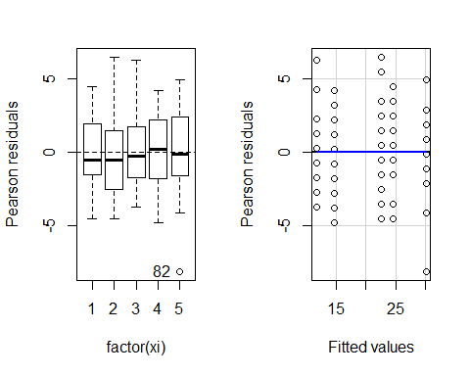

qqnorm(residuals(fit))  
qqline(residuals(fit))

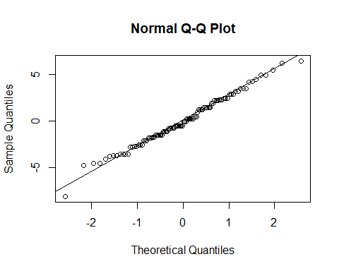

#Q2(a)  
aov(y~factor(xi), pm)

## Call:  
## aov(formula = y ~ factor(xi), data = pm)  
##   
## Terms:  
## factor(xi) Residuals  
## Sum of Squares 4430.10 714.65  
## Deg. of Freedom 4 95  
##   
## Residual standard error: 2.742742  
## Estimated effects may be unbalanced

summary(aov(y~factor(xi), pm))

## Df Sum Sq Mean Sq F value Pr(>F)   
## factor(xi) 4 4430 1107.5 147.2 <2e-16 ***  
## Residuals 95 715 7.5   
## ---  
## Signif. codes: 0 '***' 0.001 '**' 0.01 '*' 0.05 '.' 0.1 ' ' 1

plot(aov(y~xi, pm))

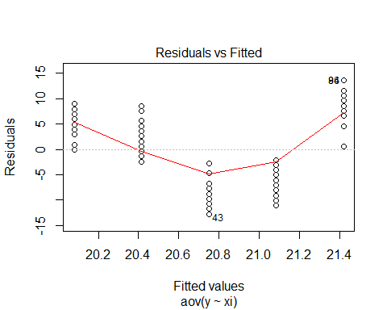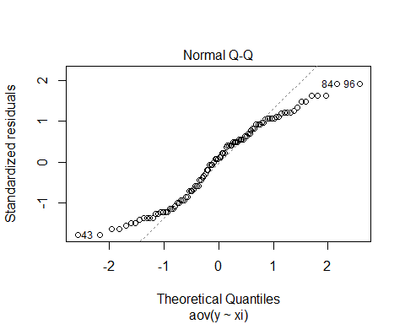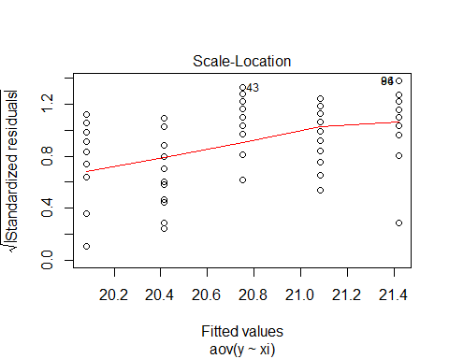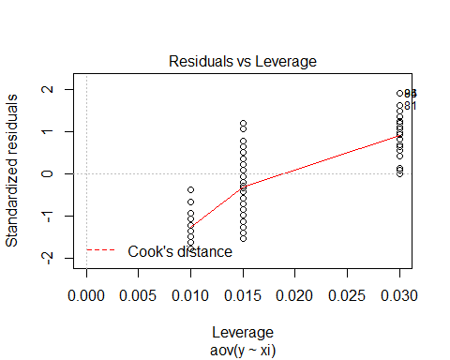

#(b)  
  
#boxplot(y~x1,data=pm)  
  
#pm1<-read.csv("C:/Users/candi/Desktop/STAT 512/premium - Copy.csv",header=FALSE,col.names=c('y','b0','x1','x2','x3','x4'), colClasses=c('numeric','factor','factor','factor','factor','factor'))  
#anova(lm(y~x1+x2+x3+x4,data=pm1))

# HW7 Programmer

prog<-read.table("C:/Users/candi/Desktop/STAT 512/programmer.txt", header=FALSE, col.names=c('y','ty','yr','n'), colClasses=c('numeric','factor','factor','factor'))  
  
#install.packages("ggpubr")  
#(a)  
interaction.plot(x.factor = prog$ty, trace.factor = prog$yr,   
 response = prog$y, fun = mean,   
 type = "b", legend = TRUE,   
 xlab = "type of experience", ylab="programmer days",  
 pch=c(1,19),col = c("#00AFBB", "#E7B800","#CA5b09"))

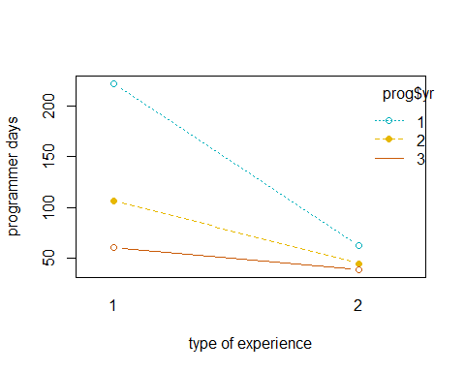

#(b)  
fitp<-lm(y~ty+yr+ty:yr, data=prog)  
summary(fitp)

##   
## Call:  
## lm(formula = y ~ ty + yr + ty:yr, data = prog)  
##   
## Residuals:  
## Min 1Q Median 3Q Max   
## -16.000 -5.062 0.375 5.875 18.000   
##   
## Coefficients:  
## Estimate Std. Error t value Pr(>|t|)   
## (Intercept) 222.000 4.640 47.84 < 2e-16 ***  
## ty2 -159.750 6.562 -24.34 3.16e-15 ***  
## yr2 -115.500 6.562 -17.60 8.64e-13 ***  
## yr3 -161.500 6.562 -24.61 2.61e-15 ***  
## ty2:yr2 98.000 9.280 10.56 3.84e-09 ***  
## ty2:yr3 138.000 9.280 14.87 1.49e-11 ***  
## ---  
## Signif. codes: 0 '***' 0.001 '**' 0.01 '*' 0.05 '.' 0.1 ' ' 1  
##   
## Residual standard error: 9.28 on 18 degrees of freedom  
## Multiple R-squared: 0.9841, Adjusted R-squared: 0.9797   
## F-statistic: 223 on 5 and 18 DF, p-value: 1.557e-15

anova(fitp)

## Analysis of Variance Table  
##   
## Response: y  
## Df Sum Sq Mean Sq F value Pr(>F)   
## ty 1 39447 39447 458.02 2.983e-14 ***  
## yr 2 36412 18206 211.39 3.158e-13 ***  
## ty:yr 2 20165 10083 117.07 4.816e-11 ***  
## Residuals 18 1550 86   
## ---  
## Signif. codes: 0 '***' 0.001 '**' 0.01 '*' 0.05 '.' 0.1 ' ' 1

options(contrasts=c("contr.sum","contr.poly"))  
library(car)

## Loading required package: carData

Anova(lm(y~ty+yr,data=prog), contrasts=list(ty=contr.sum, yr=contr.sum),type=3)

## Anova Table (Type III tests)  
##   
## Response: y  
## Sum Sq Df F value Pr(>F)   
## (Intercept) 190638 1 175.577 2.314e-11 ***  
## ty 39447 1 36.331 6.820e-06 ***  
## yr 36412 2 16.768 5.295e-05 ***  
## Residuals 21716 20   
## ---  
## Signif. codes: 0 '***' 0.001 '**' 0.01 '*' 0.05 '.' 0.1 ' ' 1

#Q6(d)  
prog["1/Y"]=1/prog$y  
prog["log(Y)"]=log10(prog$y)  
  
interaction.plot(x.factor = prog$ty, trace.factor = prog$yr,   
 response = prog$`1/Y`, fun = mean,   
 type = "b", legend = TRUE,   
 xlab = "type of experience", ylab="programmer days",  
 pch=c(1,19),col = c("#00AFBB", "#E7B800","#CA5b09"))

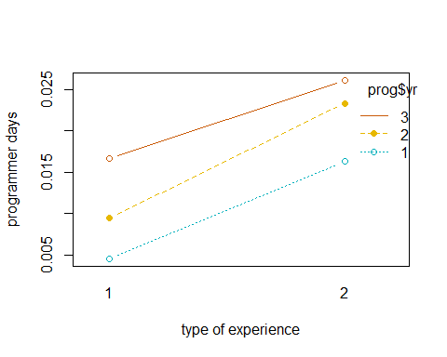

interaction.plot(x.factor = prog$ty, trace.factor = prog$yr,   
 response = prog$`log(Y)`, fun = mean,   
 type = "b", legend = TRUE,   
 xlab = "type of experience", ylab="programmer days",  
 pch=c(1,19),col = c("#00AFBB", "#E7B800","#CA5b09"))

 